IPv4 Addressing and Networks 816032904
IPv4 Addresses on interfaces for routers facing other routers.
Name | Interface | VLAN | IP Address | Subnet Mask | Network Address | Broadcast Address
PC11 | Eth0 | 81 | 192.32.90.11 | 255.255.255.128 | 192.32.90.0/25 | 192.32.90.127
PC12 | Eth0 | 81 | 192.32.90.12 | 255.255.255.128 | 192.32.90.0/25 | 192.32.90.127
PC13 | Eth0 | 81 | 192.32.90.13 | 255.255.255.128 | 192.32.90.0/25 | 192.32.90.127
PC14 | Eth0 | 81 | 192. 32.90.14 | 255.255.255. 128 | 192.32.90.0/25 | 192.32.90.127
PC21 | Eth0 | 111 | 192.32.90.131 | 255.255.255.128 | 192.32.90.128/25 | 192.32.90.255
PC22 | Eth0 | 111 | 192.32.90.132 | 255.255.255.128 | 192.32.90.128/25 | 192.32.90.255
PC23 | Eth0 | 111 | 192.32.90.133 | 255.255.255.128 | 192.32.90.128/25 | 192.32.90.255
PC24 | Eth0 | 111 | 192.32.90.134 | 255.255.255.128 | 192.32.90.128/25 | 192.32.90.255
PC25 | Eth0 | 111 | 192.32.90.135 | 255.255.255.128 | 192.32.90.128/25 | 192.32.90.255
PC31 | Eth0 | 11 | 192. 32.91.31 | 255.255.255.128 | 192. 32.91.0/25 | 192. 32.91.127
PC32 | Eth0 | 11 | 192. 32.91.32 | 255.255.255.128 | 192. 32.91.0/25 | 192. 32.91.127
PC33 | Eth0 | 11 | 192. 32.91.33 | 255.255.255.128 | 192. 32.91.0/25 | 192. 32.91.127
Server21 | Eth0 | 5 | 192.32.91.221 | 255.255.255.128 | 192.32.91.128/25 | 192. 32.91.255
Server11 | Eth0 | 5 | 192.32.91.211 | 255.255.255.128 | 192.32.91.128/25 | 192. 32.91.255

IPv6 Addressing and Networks
IPv6 Addresses on interfaces for routers facing other routers.
Name | Interface | VLAN | IP v6 Address | Prefix
PC11 | Eth0 | 81 | 2001:CAFE:8160:3290::4011/ 64 | 2001:CAFE:8160:3290::/64
PC12 | Eth0 | 81 | 2001:CAFE:8160:3290::4012/ 64 | 2001:CAFE:8160:3290::/64
PC13 | Eth0 | 81 | 2001:CAFE:8160:3290::4013/ 64 | 2001:CAFE:8160:3290::/64
PC14 | Eth0 | 81 | 2001:CAFE:8160:3290::4014/ 64 | 2001:CAFE:8160:3290::/64
PC21 | Eth0 | 111 | 2001:CAFE:8160:3290::4021/ 64 | 2001:CAFE:8160:3290::/64
PC22 | Eth0 | 111 | 2001:CAFE:8160:3290::4022/ 64 | 2001:CAFE:8160:3290::/64
PC23 | Eth0 | 111 | 2001:CAFE:8160:3290::4023/ 64 | 2001:CAFE:8160:3290::/64
PC24 | Eth0 | 111 | 2001:CAFE:8160:3290::4024/ 64 | 2001:CAFE:8160:3290::/64
PC25 | Eth0 | 111 | 2001:CAFE:8160:3290::4025/ 64 | 2001:CAFE:8160:3290::/64
PC31 | Eth0 | 11 | 2001:CAFE:8160:3290::4031/ 64 | 2001:CAFE:8160:3290::/64
PC32 | Eth0 | 11 | 2001:CAFE:8160:3290::4032/ 64 | 2001:CAFE:8160:3290::/64
PC33 | Eth0 | 11 | 2001:CAFE:8160:3290::4033/ 64 | 2001:CAFE:8160:3290::/64
Server11 | Eth0 | 5 | 2001:CAFE:8160:3290::4044/ 64 | 2001:CAFE:8160:3290::/64
Server21 | Eth0 | 5 | 2001:CAFE:8160:3290::4045/ 64 | 2001:CAFE:8160:3290::/64

  - 10) From PC11 ping the IPv4 address of the following, record commands used AND screenshots of the ping operation,
  - i) PC12
pc11> ping 192.32.90.12
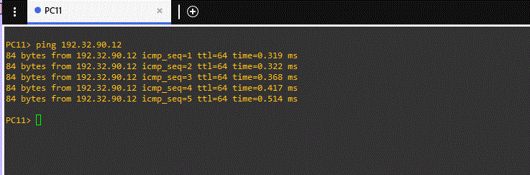

  - ii) PC14
  - pc11>ping 192.32.90.14
  - (I only got this ping to work by temporarily assigning port 7 on switch 11 vlan 111 when it supposed to be vlan 81. All other pings work as they should without temporarily changing anything.)
  - 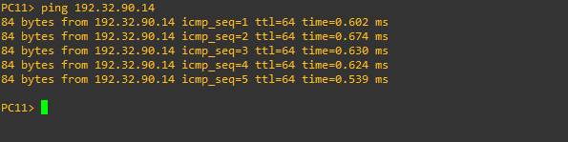

  - 11) From PC21 ping the IPv4 address of the following, record commands used AND screenshots of the ping operation,
  - i) PC22
- 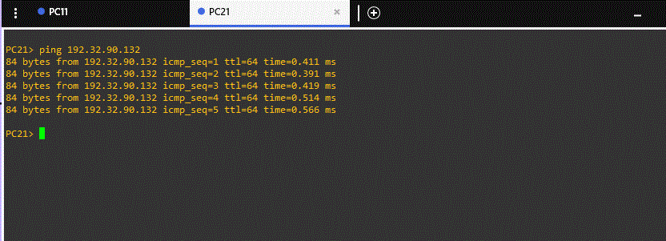

  - ii) PC25
- 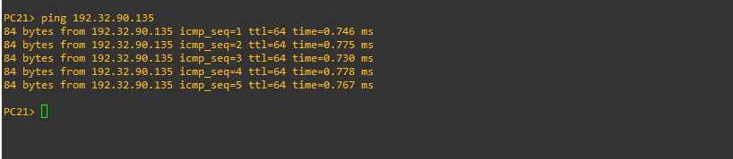

  - 12) From PC21 ping the IPv6 address of the following, record commands used AND screenshots of the ping operation,
  - i) PC24
  - PC21>ping 2001:CAFE:8160:3290::4024 -w 5000
  - 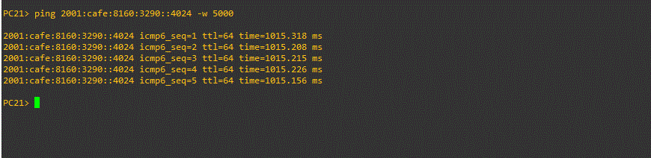

  - ii) PC25
  - PC21> ping 2001:CAFE:8160:3290::4025 -w 5000
- 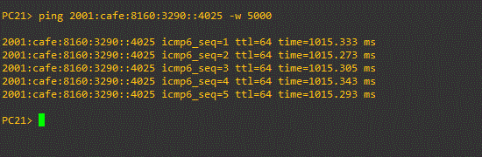
  - 13) From PC31 ping the IPv6 address of the following, record commands used AND screenshots of the ping operation,

  - i) PC32
  - PC31> ping 2001:CAFE:8160:3290::4032 -w 5000

  - 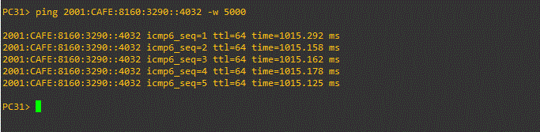

  - ii) PC33
  - PC31> ping 2001:CAFE:8160:3290::4033 -w 5000
  - 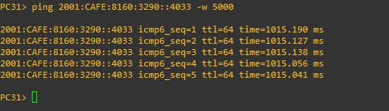
Commands Used
[used this as an example to place your commands in your work document]
PC11
ip 192.32.90.11 255.255.255.128
show ip
ip 2001:CAFE:8160:3290::4011/64 auto
show ipv6
save

PC12
ip 192.32.90.12 255.255.255.128
show ip
ip 2001:CAFE:8160:3290::4012/64 auto
show ipv6
save

PC 13
ip 192.32.90.13 255.255.255.128
show ip
ip 2001:CAFE:8160:3290::4013/64 auto
show ipv6
save

PC 14
ip 192.32.90.14 255.255.255.128
show ip
ip 2001:CAFE:8160:3290::4014/64 auto
show ipv6
save

PC 21
ip 192.32.90.131 255.255.255.128
show ip
ip 2001:CAFE:8160:3290::4021/64 auto
show ipv6
save

PC 22
ip 192.32.90.132 255.255.255.128
show ip
ip 2001:CAFE:8160:3290::4022/64 auto
show ipv6
save

PC 23
ip 192.32.90.133 255.255.255.128
show ip
ip 2001:CAFE:8160:3290::4023/64 auto
show ipv6
save

PC 24
ip 192.32.90.134 255.255.255.128
show ip
ip 2001:CAFE:8160:3290::4024/64 auto
show ipv6
save

PC25
ip 192.32.90.135 255.255.255.128
show ip
ip 2001:CAFE:8160:3290::4025/64 auto
show ipv6
save

PC31
ip 192.32.91.31 255.255.255.128
show ip
ip 2001:CAFE:8160:3290::4031/64 auto
show ipv6
save

PC32
ip 192.32.91.32 255.255.255.128
show ip
ip 2001:CAFE:8160:3290::4032/64 auto
show ipv6
save

PC33
ip 192.32.91.33 255.255.255.128
show ip
ip 2001:CAFE:8160:3290::4033/64 auto
show ipv6
save

Switch configuration:

SW12
En
Show vlan-switch brief
Vlan database
Vlan 81 Name Student
Vlan 11 Name Accounts
Vlan 111 Name Research
Vlan 5 Name Server
Vlan 999 Name BlackHole
Exit

En
Show vlan-switch brief
Conf t
Int range Fa1/0 - 1
Switchport access vlan 81
Switchport mode access
Shutdown
No Shutdown
end
Show vlan-switch brief

En
Show vlan-switch brief
Conf t
Interface Fa1/12
Switchport access vlan 11
Switchport mode access
Shutdown
no shut
End
Show vlan-switch brief

En
Show vlan-switch brief
Conf t
Interface Fa1/11
Switchport access vlan 5
Switchport mode access
Shutdown
No shut
End
Show vlan-switch brief

En
Show vlan-switch brief
Conf t
Interface range fa1/2 - 10
Switchport access vlan 999
Switchport mode access
Shutdown
No shut
End
Show vlan-switch brief

En
Show vlan-switch brief
Conf t
Interface range Fa2/0-15
Switchport access vlan 999
Switchport mode access
Shutdown
No shut
End
Show vlan-switch brief

Setting up trunk ports.
Show vlan
Conf t
Int fa1/11
Switchport mode trunk
switchport trunk encapsulation dot1q
Shutdown
No shutdown
End
Show vlan

Show vlan
Conf t
Int fa1/13
Switchport mode trunk
switchport trunk encapsulation dot1q
Shutdown
No shutdown
End
Show vlan

En
Show int trunk
Conf term
Interface range Fa1/14 - 15
Switchport trunk
switchport trunk encapsulation dot1q
Shutdown
No shutdown
End
Show vlan

Show vlan
show interfaces trunk
Conf t
Interface Fa1/11
switchport trunk allowed vlan remove 999
end
Show interfaces trunk

Show vlan
show interfaces trunk
Conf t
Interface Fa1/13
switchport trunk allowed vlan remove 999
end
show interfaces trunk

En
show interfaces trunk
Conf t
Interface range Fa1/14 - 15
Switchport trunk allowed vlan remove 999
End
show interfaces trunk
Write memory

Switch 22
En
Vlan database
Vlan 111 name Research
Vlan 5 name Server
Vlan 999 name BlackHole
Exit

Show vlan-switch brief
Conf t
interface range Fa1/0 – 1
Switchport access vlan 111
Switchport mode access
Shutdown
No Shutdown
end

En
Show vlan-switch brief
Conf t
Interface Fa1/12
Switchport access vlan 5
Switchport mode access
Shutdown
no shut
End
Show vlan-switch brief

En
Show vlan-switch brief
Conf t
Interface range Fa1/2 - 12
Switchport access vlan 999
Switchport mode access
Shutdown
No shut
End
Show vlan-switch brief

En
Show vlan-switch brief
Conf t
Interface Fa1/15
Switchport access vlan 999
Switchport mode access
Shutdown
No shut
End
Show vlan-switch brief

En
Show vlan-switch brief
Conf t
Interface range Fa2/0 - 15
Switchport access vlan 999
Switchport mode access
Shutdown
No shut
End
Show vlan-switch brief

En
Show vlan-switch brief
Configure t
Interface 1/13
Switchport access vlan 5
Switchport mode access
Shutdown
No shutdown
End
Show vlan-switch brief

En
Show vlan-switch brief
Conf t
Interface Fa1/14
Switchport mode trunk
switchport trunk encapsulation dot1q
Shutdown
No shutdown
End
Show vlan-switch brief

En
Show int trunk
Conf term
Interface range Fa1/14
Switchport trunk allowed vlan remove 999
End
Show int trunk
Write memory

SW21
En
Vlan database
Vlan 111 name research
Vlan 5 Name Server
Vlan 999 Name BlackHole
Exit

En
Show vlan-switch brief
Conf t
Int range Fa1/0 - 1
Switchport access vlan 111
Switchport mode access
Shutdown
No Shutdown
end
Show vlan-switch brief

En
Show vlan-switch brief
Conf t
Interface range Fa1/2-13
Switchport access vlan 999
Switchport mode access
Shutdown
No shut
End
Show vlan-switch brief

En
Show vlan-switch brief
Conf t
Interface range fa2/0-15
Switchport access vlan 999
Switchport mode access
Shutdown
No shut
End
Show vlan-switch brief

Setting up trunk ports.
Show vlan-switch brief
Conf t
Interface range Fa1/14 to 15
Switchport mode trunk
switchport trunk encapsulation dot1q
Shutdown
No shutdown
End
Show vlan-switch brief

En
Show int trunk
Conf term
Interface range Fa1/14 to 15
Switchport trunk allowed vlan remove 999
End
Show int trunk
Write memory

